UNO! Whose Turn?

Goal of this invention is to allow the players to enjoy the game instead of focusing on the game mechanics.

Game mechanics can be but not limited to rules, score keeping, dealer tracking, error detection, tracking whose turn it is, and so on.

One way to better understand it is playing a multiplayer UNO game on mobile app. In the UNO game on the app, you can enjoy focusing on playing the game instead of focusing on the mechanics because the UNO game app does the mechanics for the players.

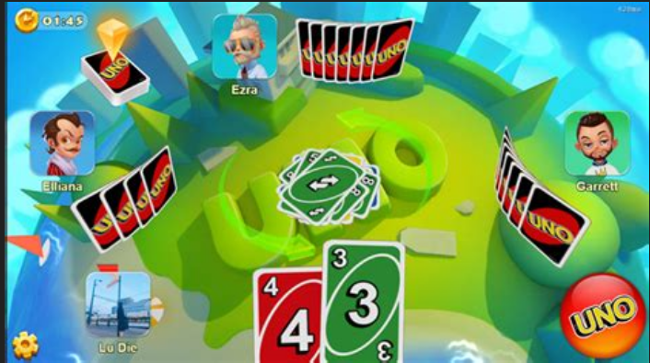
When you play UNO in person, you will notice the difference, the confusion, and so on.

Before completing this project, a final test to make sure it works well must be done while playing a normal round with real players. If the game feels as natural as playing UNO on a mobile app and there is no glitch, errors, and so on, then should be good to go.

